 | CLB 1-4 LISTENING SKILL USING:  Follow directions at the supermarket

Possible Skill-Building Activities:
Target language
- CLB 1: It’s in aisle ___.
- CLB 2: It’s in aisle ___ on the right/left.
- CLB 3: You’ll find it in aisle ___, on the right-hand/left-hand side, on the top/middle/bottom shelf.
- CLB 4: It’s in the back left/right corner of the store. You will find ___ right beside/next to the produce section. It’s across from the ___ section. You’ll see the ___ section straight ahead of you.
Store directions activities
- Numbers: https://www.languageguide.org/english/numbers/
- Grocery store sections: https://www.learningchocolate.com/content/grocery-store
- Lit-CLB 1 Let’s go shopping for food: http://olip-plio.ca/wp-content/uploads/2017/04/Shopping-Lit-CLB-1-2016.pdf
- CLB 1 Pharmacy customers ask: https://tutela.ca/Resource_18027
- CLB 1-2 Can you help me?: https://janis-esl.issbc.org/wp-content/uploads/articulate_uploads/Can-you-help-me/story_html5.html
- At the grocery store – I’m looking for…: https://www.youtube.com/watch?v=h9FqUo2I7EM
- Grocery store vocabulary: https://youtu.be/NG-de6quWkE
- Shopping at the supermarket: https://youtu.be/wMf4GbUJhv4
- Grocery shopping phrases: https://youtu.be/TL0d7PhBmxs
- Place prepositions: https://www.learningchocolate.com/content/prepositions-place
- More place prepositions: https://www.learningchocolate.com/content/prepositions-place-0
- In the supermarket – next to, by, in, behind: https://www.youtube.com/watch?v=ytEg4hqc4fI
- In the supermarket – Where can I find…?: https://www.youtube.com/watch?v=ItdgJY_4PV4
- CLB 1-2 Shop for food: https://tutela.ca/Resource_35130
- CLB 2 Where can I find toothpaste?: https://tutela.ca/Resource_1475
- CLB 2-3 Let’s go shopping for food: http://olip-plio.ca/wp-content/uploads/2017/04/Shopping-CLB-2-3-2016.pdf
- CLB 3 Asking for and receiving help when shopping: https://tutela.ca/Resource_1632
- CLB 3-4 Shop for groceries: https://tutela.ca/Resource_35037
- CLB 4-5: Let’s go shopping for food: http://olip-plio.ca/wp-content/uploads/2017/04/Shopping-CLB-4-5-2016.pdf
- Grocery shopping in English: https://www.englishclub.com/efl/survival/grocery-shopping/
- Directions: https://www.learningchocolate.com/content/directions-1
- How to ask for directions and how to give directions: https://youtu.be/hKLhepR2KY4
- Imperatives: https://continuingstudies.uvic.ca/elc/studyzone/330/grammar/imperat
- Imperatives - How to give commands in English: https://youtu.be/lDtaFNLov4Y
**Note: See the following pages for skill-using tools.**

Name: _______________________________ Date: _____________
CLB 1 LISTENING SKILL USING:
Follow directions at the supermarket
1.2 Comprehending Instructions • I can understand very short, simple instructions.
INSTRUCTIONS: Read the questions. Circle your answers.
1. This listening was…
 |  | easy |  | so-so | hard
2. I listened…
1 |  | 2 |  | 3 | 4+
time |  | times |  | times | times
3. My answer was…
 |  | correct |  |  | incorrect
4. I will practise listening by…
 |  | 123
doing my homework | studying my class notes | listening to numbers | asking for help in English | talking to  my classmates | watching English  videos
My teacher says:

Name: _______________________________ Date: _____________
CLB 2 LISTENING SKILL USING:
Follow directions at the supermarket
2.2 Comprehending Instructions • I can understand short, simple, common
directions.
INSTRUCTIONS: Read the questions. Circle your answers.
1. This listening was…
 |  | easy |  | so-so |  | hard
2. I listened…
1 |  | 2 |  | 3 |  | 4+
time |  | times |  | times |  | times
3. My answer was…
 |  | correct |  |  |  | incorrect
4. I will practise listening by…
 |  | 123
doing my homework | studying my  class notes | listening to numbers | asking for help in English | listening to directions | talking to my classmates |  | watching videos
My teacher says:
Name: _______________________________ Date: _____________
CLB 3 LISTENING SKILL USING:
Follow directions at the supermarket
3.2 Comprehending Instructions • I can understand common instructions and directions.
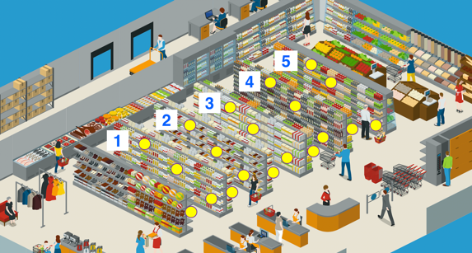
INSTRUCTIONS: Read the questions. Circle your answers.
1. (a) This listening was…
 |  |  | easy |  |  |  | so-so |  |  | Hard
(b) Challenges:

vocabulary  (I didn’t know all the words.) |  |  |  | speed  (It was fast.) |  | length  (It was long.) |  |  | sound/volume  (It was hard to hear.)
 |  |  |  |  |  |  |  |  | other:
instructions  (I didn’t understand the instructions.) |  |  |  | technology  (I had problems with my device/internet.) |  | pictures/words  (The pictures and/or words were hard to see.)
2. I listened…
1 |  |  | 2 |  |  |  | 3 |  |  | 4+
time |  |  | times |  |  |  | times |  |  | times
3. My answer was…
 |  |  | Correct |  |  |  |  |  |  | incorrect
4. I will practise listening by…
 |  |  | 123
doing my homework | studying my  class notes |  | listening to numbers |  | asking for help in English |  | listening to directions | talking to my classmates |  |  | watching videos
My teacher says:

Name: _______________________________ Date: _____________
CLB 4 LISTENING SKILL USING:
Follow directions at the supermarket
4.2 Comprehending Instructions • I can understand common instructions and directions for familiar everyday situations.
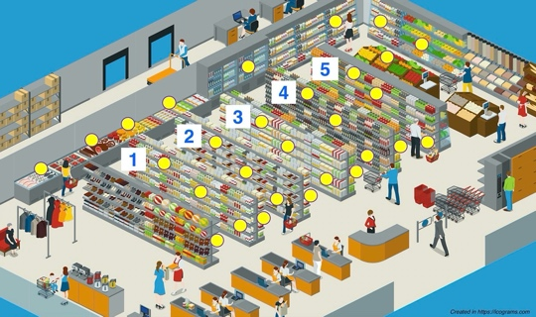
INSTRUCTIONS: Read the questions. Circle your answers.
1. This listening was…
 |  | easy |  |  |  | so-so |  |  | Hard
(b) Challenges:
vocabulary  (I didn’t know all the words.) |  |  | speed  (It was fast.) |  | length  (It was long.) |  |  | sound/volume  (It was hard to hear.)
 |  |  |  |  |  |  |  | other:
instructions  (I didn’t understand the instructions.) |  |  | technology  (I had problems with my device/internet.) |  | pictures/words  (The pictures and/or words were hard to see.)
2. I listened…
1 |  | 2 |  |  |  | 3 |  |  | 4+
time |  | times |  |  |  | times |  |  | times
3. My answer was…
 |  | correct |  |  |  |  |  |  | Incorrect
4. I will practise listening by…
 |  | 123
doing my homework | studying my  class notes | listening to numbers |  | asking for help in English |  | listening to directions | talking to my classmates |  |  | watching videos
My teacher says:

